**Heuristic 1**

1. How do you evaluate the states with this heuristic? Add one example.

The first heuristic we propose estimates the number of times one has to move the red piece in order to complete the puzzle. For this estimation it is assumed that there are no yellow pieces in play making it really easy to complete an estimation, here is an example:

State:  Heuristic estimation: 

In this example it is easy to see that if we were to ignore the yellow pieces, the puzzle could be completed in 3 steps, so this state would receive a heuristic estimation of h(n) = 3.

1. Is this an admissible heuristic? Justify your answer.

It is admissible because it underestimates the number of moves that it will take to solve the puzzle. In fact, even if there were no yellow blocks, the number of moves it would take to solve it would be *at least* the number of moves the heuristic computes, so the admissibility condition h(n) <= h*(n) is met.

**Heuristic 2**

1. How do you evaluate the states with this heuristic? Add one example.

The second heuristic we propose consists in counting the number of yellow pieces to the left or below the red piece (troublesome pieces) to estimate the number of moves we need to clear the path in order to solve the puzzle. We choose the pieces to the left and below the red piece because those are the pieces directly blocking the goal of the red piece while the ones that are right or up are already “out of the way”. Here is an example:

State:  Heuristic estimation: 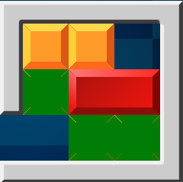

Here the 3 pieces highlighted in green are counted by the heuristic estimation so that h(n) = 3.

1. Is this an admissible heuristic? Justify your answer.

It is admissible because it assumes that you will need *at least* 1 action per yellow piece to get the piece out of the way. When the puzzle is almost solved it takes exactly one action to move the troublesome pieces out of the way, but more often than not this will be an underestimation since it will take more than one move per troublesome piece, so h(n) <= h*(n).